|  |  |  |  |
| --- | --- | --- | --- |
| logo_ec_17_colors_300dpi | | **EUROPEAN COMMISSION**  DIRECTORATE-GENERAL INFORMATICS  Directorate B - Digital Business Solutions  DIGIT.B.2. - Corporate Knowledge and Decision Making Solutions | |
|  |  | |  | |

e-TrustEx Web Access

**Quick Start Guide**

|  |  |
| --- | --- |
| Date: | 15/10/2015 |
| Version: | 1.0 |
| Author: | Razvan IONESCU |
|  |  |

Contents

[1. Introduction 3](#_Toc432761624)

[2. e-TrustEx Platform Overview 4](#_Toc432761625)

[3. European Commission Authentication Service (ECAS) 6](#_Toc432761626)

[4. Accessing e-TrustEx Web Access 7](#_Toc432761627)

[5. The Home Page 8](#_Toc432761628)

[Page Header 9](#_Toc432761629)

[Navigation Menu 9](#_Toc432761630)

[The Inbox 9](#_Toc432761631)

[6. The Message Details page 11](#_Toc432761632)

[Message Header 12](#_Toc432761633)

[Message Body 12](#_Toc432761634)

[List of Documents 13](#_Toc432761635)

[List of Files 13](#_Toc432761636)

# Introduction

**What is e-TrustEx?**

e-TrustEx (electronic-Trusted Exchange) is a generic communication platform that facilitates the secure exchange of electronic documents between public authorities at European, national and local level via standardised interfaces.

**What e-TrustEx offers**

* Electronic exchange of documents(structured and unstructured)
* Support for large volumes:
  + Up to 100 Mb per file
  + Up to 500 files per transmission
* Advanced security features (encryption, integrity)

**What are the benefits of e-TrustEx?**

* Enable the automation of business processes
* Reduce overall cost of documents exchange
* Improve the confidentiality and integrity of the transmission

# **e-TrustEx Platform Overview**

e-TrustEx is a generic communication platform allowing two organizations, one being the sender and the other one the receiver, to exchange electronic documents.

**Sender and Receiver Parties**

Each organization is considered a "party" in the communication process and it is identified in the platform by its "party name" (a virtual identifier for the organization). Several parties can be defined for one organization.

**Interchange Communication Agreement (ICA)**

In order to exchange documents via e-TrustEx a communication agreement has to be defined in the e-TrustEx platform between the sender and the receiver parties. This agreement is called Interchange Communication Agreement (ICA). In addition to the sender and receiver parties an ICA also defines some attributes for the communication between the two like the security and integrity levels.

The e-TrustEx platform consists of three main components as shown in the picture below:

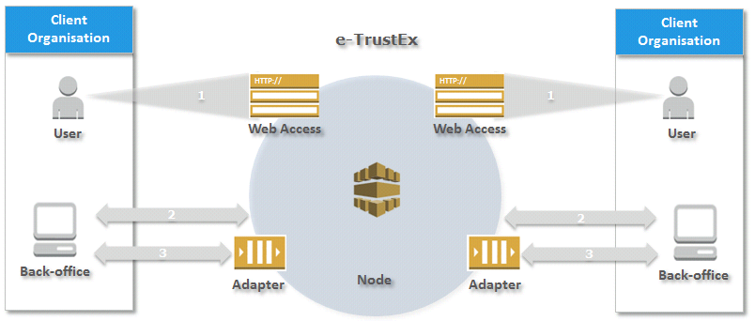

**e-TrustEx Node**

The e-TrustEx Node is the central component of the platform in charge of routing transmissions from the sender to the receiver.

**e-TrustEx Adapter**

The e-TrustEx Adapter is a technical integration component allowing a client information system to interact directly with the e-TrustEx platform without human intervention.

This component allows system-to-system interaction and it is intended to organizations that plan to automate the exchange of documents by connecting their information systems to the e-TrustEx platform.

**e-TrustEx Web Access**

e-TrustEx Web Access is a web based user interface allowing a human operator to interact with the e-TrustEx platform for sending and receiving documents.

This component allows human-to-system interaction and it is intended to organizations that do not have an information system or do not plan to connect their information systems to the e-TrustEx platform.

# European Commission Authentication Service (ECAS)

Accessing European Commission's information systems requires users to be registered with the European Commission's Authentication Service (ECAS). The registration process requires the interested user to open a user account (ECAS account) identified by a user name and protected by a password.

The ECAS account is personal and can only be created by the interested user and not by the Commission.

Once the user created a personal ECAS account, rights to access different information systems made available by the European Commission can be granted to the account. For this the interested user needs to contact the service in charge of the related information system and ask access, communicating in the same time the personal ECAS account to which rights should be granted.

The registration process with the European Commission's Authentication Service is described in a separate document.

# Accessing e-TrustEx Web Access

e-TrustEx Web Access is available by accessing the following address:

<https://webgate.ec.europa.eu/e-trustex>

The user will be automatically redirected to the European Commission's Authentication Service (ECAS) and will be requested to authenticate with his personal ECAS account.

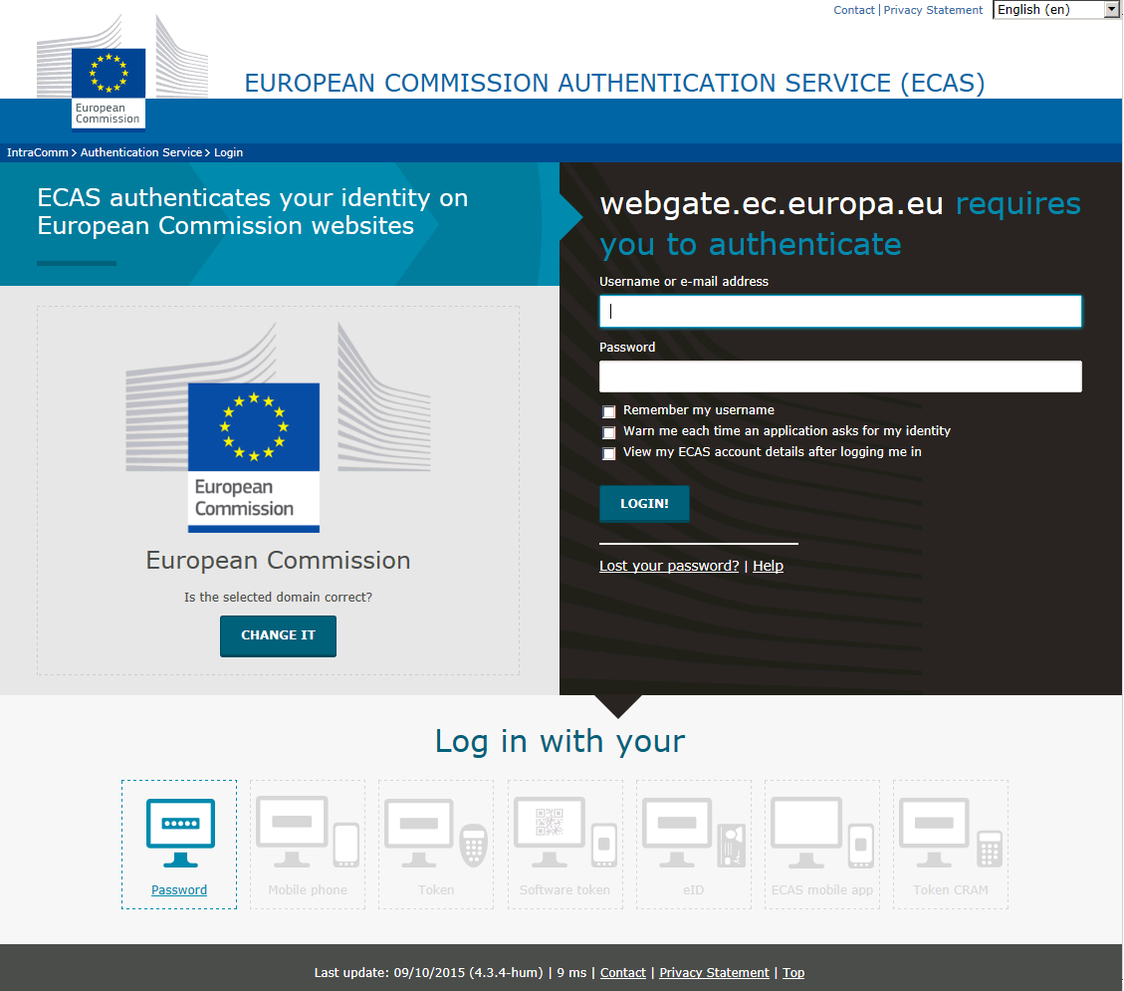

If the authentication succeeds the user is automatically redirected to the e-TrustEx Web Access home page and can start using the application.

# The Home Page

The home page of e-TrustEx Web Access application is shown in the picture below:

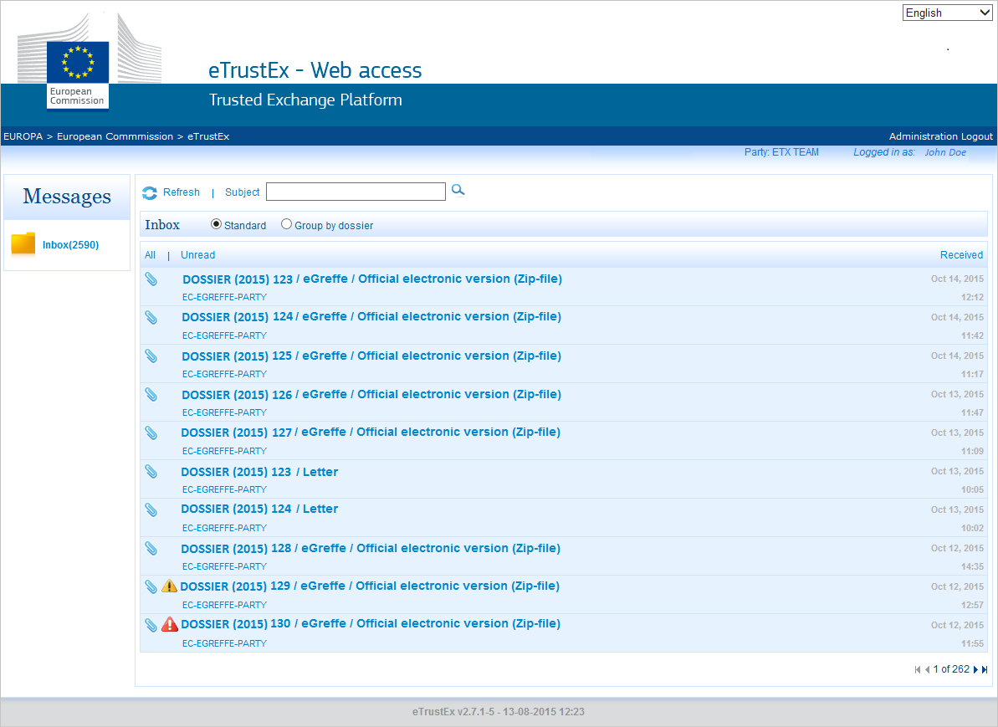

The home page consists of the following elements:

## Page Header

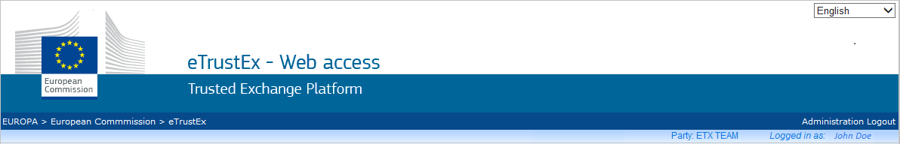

The following elements are displayed in the page header:

* Language selection functionality

H:\My Documents\Projects\eTrustEx\Documentation\eTrustEx Web Access\ETX-Inbox language selection.png

* Connected organization identified by its party name

H:\My Documents\Projects\eTrustEx\Documentation\eTrustEx Web Access\ETX-Inbox party name.png

* Connected user

H:\My Documents\Projects\eTrustEx\Documentation\eTrustEx Web Access\ETX-Inbox user name.png

## Navigation Menu

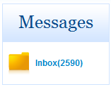The navigation menu is located in the left part of the page and allows users to navigate between the Inbox, the Outbox or the Draft messages box.

The Inbox option is visible by default to all the parties.

The Outbox and the Draft messages box are visible only to the parties for which a bi-directional communication channel has been setup (they can receive and send messages).

## The Inbox

The Inbox is located in the central part of the page and it displays the list of received messages. It also offers additional functionalities for searching and grouping messages.

It contains the following elements:

* Refresh functionality - refresh the list of messages

H:\My Documents\Projects\eTrustEx\Documentation\eTrustEx Web Access\ETX-Inbox refresh.png

* Search functionality - search messages by subject

H:\My Documents\Projects\eTrustEx\Documentation\eTrustEx Web Access\ETX-Inbox search.png

* Group functionality - view messages grouped by dossier or in standard way (ungrouped)

H:\My Documents\Projects\eTrustEx\Documentation\eTrustEx Web Access\ETX-Inbox group.png

* List of received messages



Messages in the list can be filtered (All or Unread) and sorted (by the reception date/time) using the filter and sort functionalities:

H:\My Documents\Projects\eTrustEx\Documentation\eTrustEx Web Access\ETX-Inbox sort.png

The following elements are displayed for each message in the list:

* Message subject

H:\My Documents\Projects\eTrustEx\Documentation\eTrustEx Web Access\ETX-Inbox message subject.png

* Sender organization identified by its party name

H:\My Documents\Projects\eTrustEx\Documentation\eTrustEx Web Access\ETX-Inbox message party.png

* Date and time when the message was received

H:\My Documents\Projects\eTrustEx\Documentation\eTrustEx Web Access\ETX-Inbox message datetime.png

* Retention period warnings

The attached documents are available for download for a period of 12 weeks stating from the date the message was received. After this period elapses the documents can no longer be downloaded.

Three days before the retention period elapses the related messages are marked with:

H:\My Documents\Projects\eTrustEx\Documentation\eTrustEx Web Access\ETX-Inbox expiry warning.png

The messages for which the retention period already elapsed are marked with:

H:\My Documents\Projects\eTrustEx\Documentation\eTrustEx Web Access\ETX-Inbox expiry.png

* Page count and page navigation functionality

H:\My Documents\Projects\eTrustEx\Documentation\eTrustEx Web Access\ETX-Inbox page count.png

# The Message Details page

Individual messages can be accessed by selecting them in the Inbox on the home page. The Message Details page then displays the details of the selected message.

*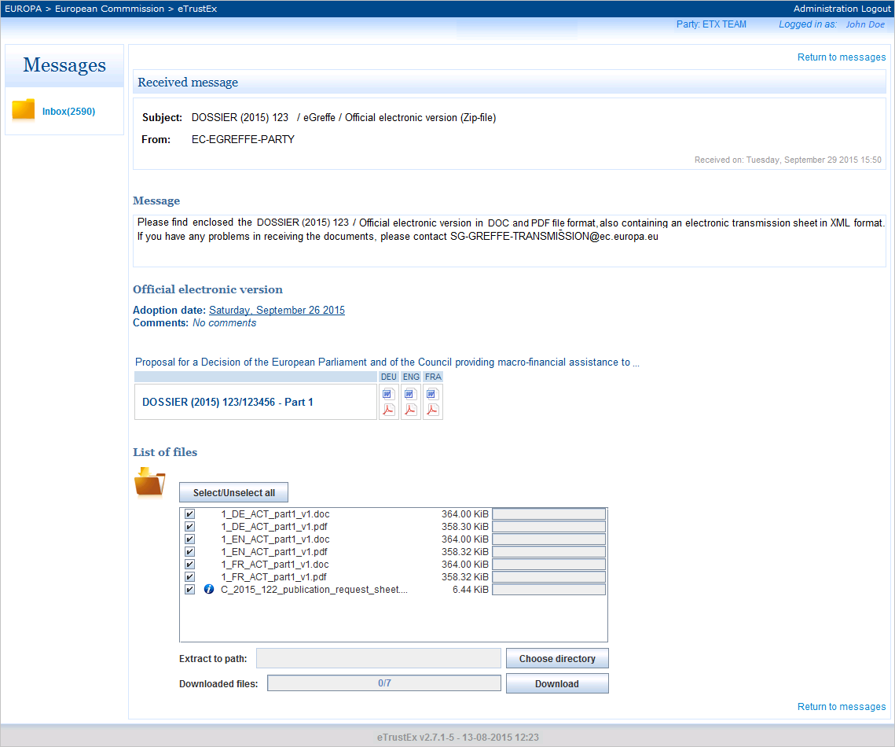*

## Message Header



It displays the following elements:

* Message subject

H:\My Documents\Projects\eTrustEx\Documentation\eTrustEx Web Access\ETX-Message subject.png

* Sender organization identified by its party name

H:\My Documents\Projects\eTrustEx\Documentation\eTrustEx Web Access\ETX-Message sender.png

* Date and time when the message was received

H:\My Documents\Projects\eTrustEx\Documentation\eTrustEx Web Access\ETX-Message datetime.png

## Message Body

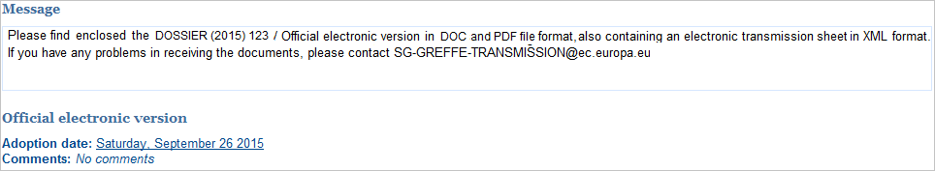

It displays the following elements:

* Message text



* Additional information (the adoption date of the act, comments)

H:\My Documents\Projects\eTrustEx\Documentation\eTrustEx Web Access\ETX-Message additional info.png

## List of Documents

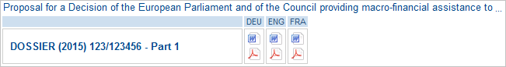

It displays the list of documents with the following details for each document:

* Short description

H:\My Documents\Projects\eTrustEx\Documentation\eTrustEx Web Access\ETX-Message description.png

* Document reference

H:\My Documents\Projects\eTrustEx\Documentation\eTrustEx Web Access\ETX-Message reference.png

* Linguistic versions

H:\My Documents\Projects\eTrustEx\Documentation\eTrustEx Web Access\ETX-Message linguistic version.png

* File format(s)

H:\My Documents\Projects\eTrustEx\Documentation\eTrustEx Web Access\ETX-Message file format.png

## List of Files

It displays the list of the attached files corresponding to the list of documents, the related linguistic version(s) and file format(s). The file size and an individual download progress bar are displayed for each file.

An additional file is included in each transmission: the transmission metadata file (or IMMC file).

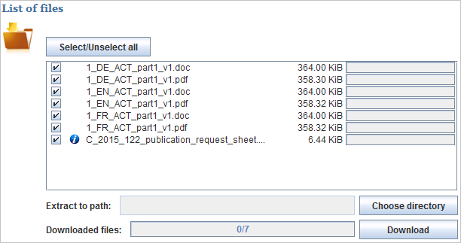

It contains the following elements:

* Bulk selection functionality - allows users to select/unselect all the files

H:\My Documents\Projects\eTrustEx\Documentation\eTrustEx Web Access\ETX-Message file all selection.png

* Individual selection functionality - allows users to select/unselect individual files

H:\My Documents\Projects\eTrustEx\Documentation\eTrustEx Web Access\ETX-Message file selection.png

* Download functionality - allows users to download the files and save them locally
  + Download location selection functionality - allows users to specify a location where the files will be downloaded

H:\My Documents\Projects\eTrustEx\Documentation\eTrustEx Web Access\ETX-Message file download location.png

* + Download button - triggers the download of the selected files

H:\My Documents\Projects\eTrustEx\Documentation\eTrustEx Web Access\ETX-Message file download.png

* + Download progress bar - displays the progress of the download

H:\My Documents\Projects\eTrustEx\Documentation\eTrustEx Web Access\ETX-Message file download progress.png

**e-TrustEx Web Access**

<https://webgate.ec.europa.eu/e-trustex>

Technical support: EC-ETRUSTEX-SUPPORT@ec.europa.eu